Title of Lesson: | How did we get here?
Teacher: | Hannah Ayers
Medium/technique: | Drawing/Pencil/Pen/Markers
Date to be Taught: | 3-9-2017

Key concepts about medium/technique:
- Crayons, which are available at a range of price points, are easy to work with, often less messy than paints and markers, blunt (removing the risk of sharp points present when using a pencil or pen), typically non-toxic, and are available in a wide variety of colors.
- These characteristics make them particularly good instruments for teaching small children to draw in addition to being used widely by student and professional artists.

Fine Arts Goals Met by the Objectives:
- Express and interpret information and ideas.
- The arts are forms of communication extending beyond reading, writing, listening and speaking. Communicating in the fine arts means learning to translate ideas through dance, drama, music and visual arts. Students also participate in the communication process as receivers– observing, analyzing, evaluating, critiquing and interacting.
- Recognize and apply connections of important information and ideas within and among learning areas.
- Through this lesson, students observe how art can reflect everyday life. They see links between the individual and society in the creation and understanding of works of art.
Vocabulary Acquisition: [definitions from Artlex.com and Wikipedia.org]
- Movement: an act of changing physical location or position or of having this changed.

Contemporary/Historical/Multicultural exemplars:
- William Anastasi, Pocket Drawings, 1969.
- William Anastasi, Untitled (Subway Drawing), 2009
- William Anastasi, Untitled (Subway Drawing), 1973

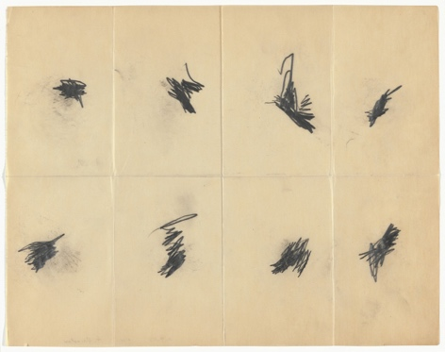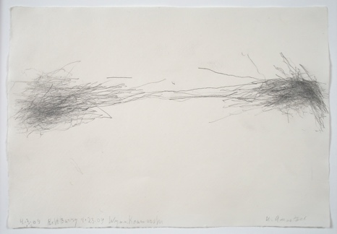

Artmaking Materials Needed:
- 26 pieces 11” x 14” paper, passed out after demo
- An assortment of drawing utensils including pencils, pens, markers, colored pencils in a pencil box set at each table.

Procedures:
- INTRODUCTION: (5 minutes)
  - Hello, I am Hannah and I am going to be teaching your art class for the next few weeks! I have here some sketchbooks for you. I am going to pass them out and I’d like for you to write your name on the cover with a simple drawing of something you like a lot.
  - Pass out the sketchbooks.
  - How many of you have had a sketchbook or a journal before?
  - Explain to them that sketchbooks are valuable for artists because it gives them a place to try out ideas before making an artwork, it gives them a place to write down research and thoughts about what to make art about, it also gives them a place to write information they learn about other artists. Sketchbooks can be like a work of art in their own way. So we are going to treat these very special and write in them and draw in them often.
  - I will explain that they stay in the classroom and I’ll collect them at the end of class. I will explain that sometimes I will give them a question to answer in their sketchbooks and I will be reading their responses and grading them.
  - From here introduce the theme of movement: “We are going to be focusing on movement over the next few weeks. In your sketchbooks, I’d like you to write a few examples of ways people move and reasons why people move.”
  - Ask for a few people to share and write the thoughts on the board. Explain that we are going to look at the work of William Anastasi. He made artwork while walking and taking the subway. Ask, “Why do people walk or take the subway?” Answer: To get someplace! (Accept whatever answers they offer as well)

- DEMONSTRATIONS: (10 minutes)
  - I will project the image of Anastasi’s drawing’s and explain how he made this artwork.
    - From MOMA: “Anastasi folded these sheets into eight squares, making them small enough to fit into his pocket. As he walked, he held a tiny, soft pencil against the exposed paper inside the cramped space of his pocket; the resulting marks graph his movements. When he deemed a section complete, Anastasi refolded the sheet, creating a new blank surface, and the process began again. “I love walking,” the artist has explained. “I find that walking does something to my thinking, to my mental process, that is different from sitting or lying down.” These “pocket drawings” are part of a broader practice that Anastasi has described as “unsighted,” including works made while walking (holding a pad, he looks at his destination as he draws) and riding the subway (the train’s stops and starts, bumps and turns, direct the line’s size, weight, and orientation).”
  - From here I will give a demo of the activity.
    - “For today’s activity we are going to make out own movement drawing. We will consider our movements from the time we woke up until this moment. We can do this with a zig-zag line, a spiral, a wavy line, there are so many ways. The movement of the line should match up with how much you were moving. For example: When you woke up this morning, you might have laid in bed for a few minutes before getting up so your line hasn’t moved much yet. Then you decide to get out of bed and move over to your dresser to get your clothes out to get dressed for school, so your line starts to move a bit more. Now you’re walking to the kitchen, so your line picks up a bit more. You finish getting ready for school and now you’re running out to catch the bus! So, your line gets really big. And then you continue this pattern through all your motions up until this moment and that is when you can stop.”
    - As you are giving the directives, you will go through the motions and create a drawing on the board.
    - At this point, hand out the sheets of paper and have them select a drawing utensil from the box on their tables and begin the drawing.

- DESIGN/WORK SESSION: (15 minutes)

  - The students should have selected a drawing utensil and began their drawings.
  - Students will work on drawings while teacher walks around assisting with ideas when/if necessary.
  - Teacher gives 3 minute time warning.
  - When the students are done have them look around at the other drawings and make some observations.

- CLEAN UP: (5 minutes)
  - They should take their drawings and fold them up so they fit in their sketchbooks and we will tape or staple the in to the book. Do this in a way that they can open and close the drawing at will to see it.
  - Put the drawing utensils back and grab a pencil for last writing activity.

- CLOSURE: (5 minutes)
  - I will ask them to write a response in their sketchbooks for “We all started by waking up and we are all sitting here now, but the time in between can vary a lot from person to person. What might the differences in our daily movements say about us as individuals?”
  - I will ask them to consider the way they move throughout the week and next week we will share our favorite movement with the class.
  - Collect their sketchbooks.

- ASSESSMENT: [separate from class time]
    - I will read their written response and see how much thought they put into it.
    - I will assess their drawing and make sure they were engaged and creative in the assignment.

https://www.moma.org/collection/works/90658?locale=en

